CAR RECORDS APP MANUAL

yOUR DETAILS

NAME & Surname

2022

Table of Contents

Use Case diagram 2

User manual/documentation 3

First Page 3

Inserting Car Records 4

Viewing Car Records 5

Deleting records 6

Database & Tables 7

# Use Case diagram

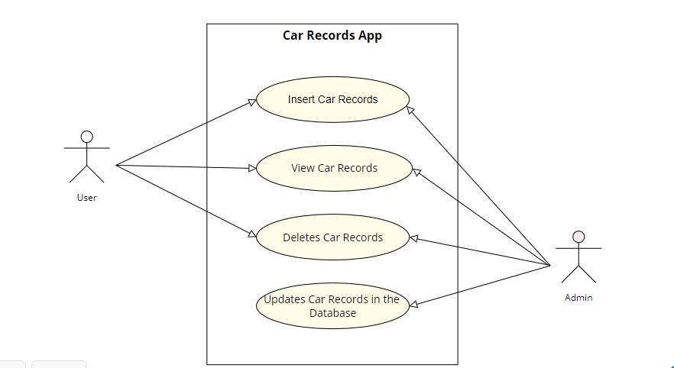

Above is the UML Use Case Diagram for the Car Records App whereby the user can only insert car records, view as well as well delete them while the admin is also able to update the records of cars at backend which is the database.

# User manual/documentation

# First Page

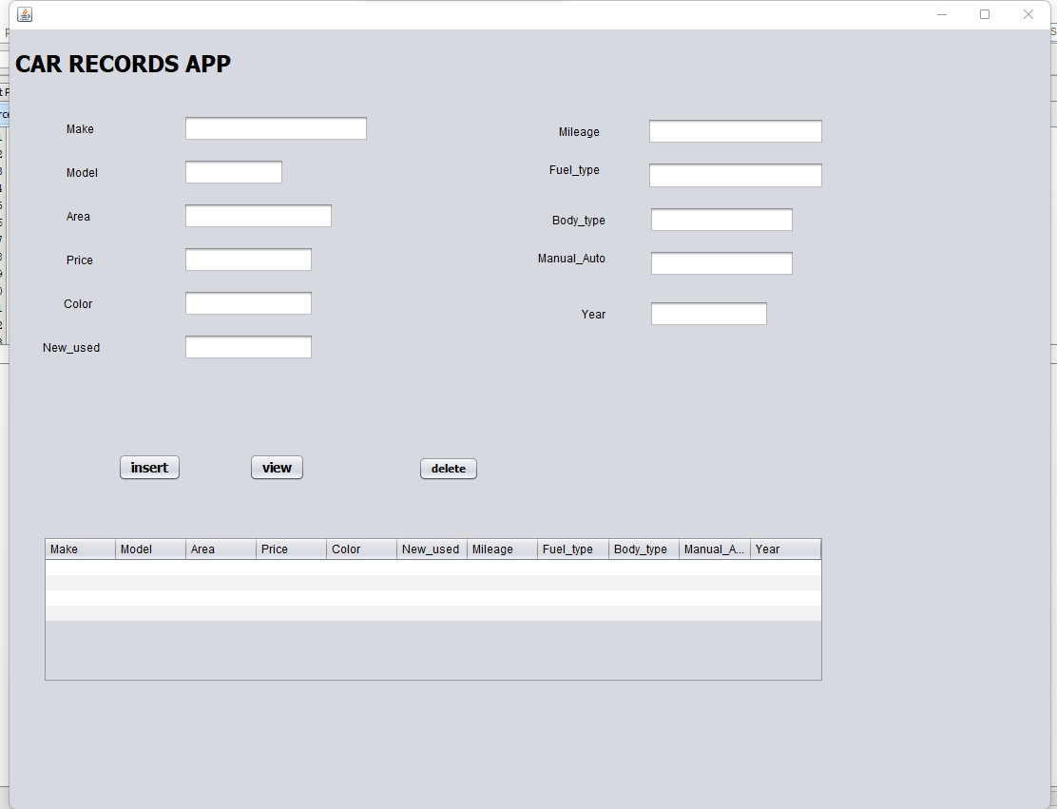

This is the first page also known as the landing page which contains all features to use on the application.

# Inserting Car Records

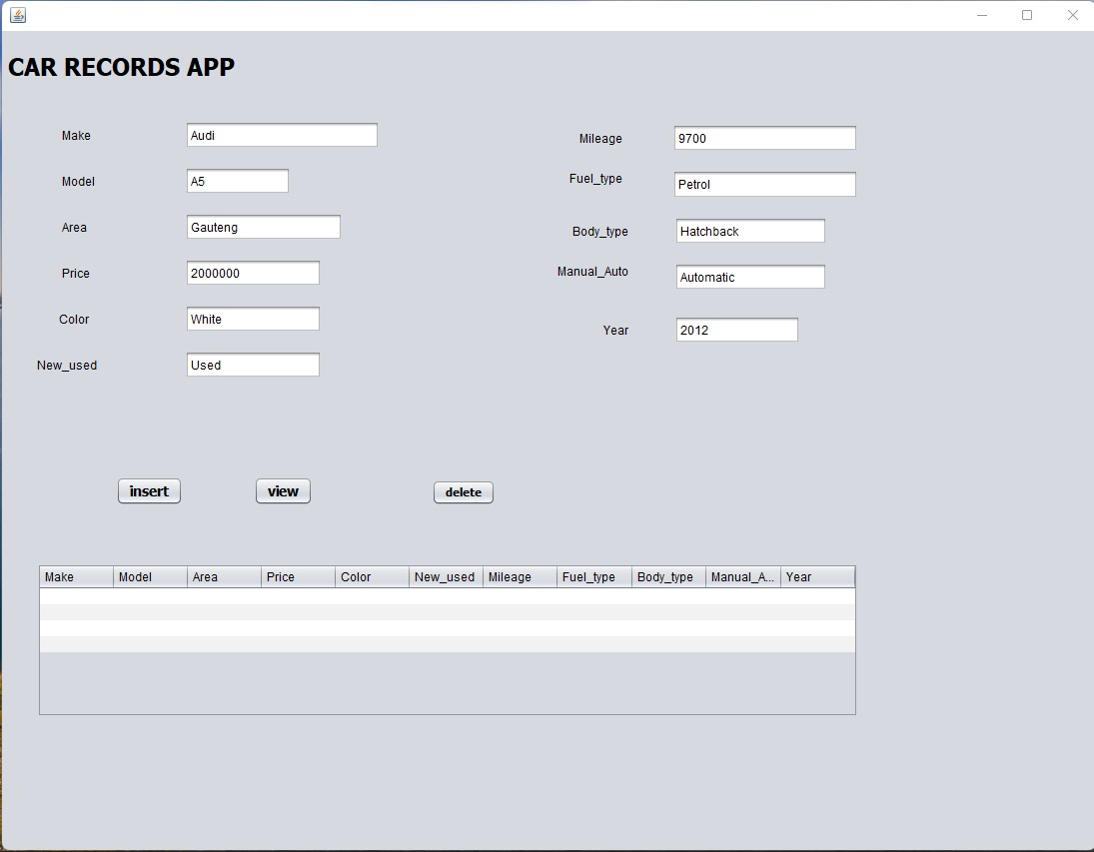

Above is the insertion of car records into the database using the **insert button.**

# Viewing Car Records

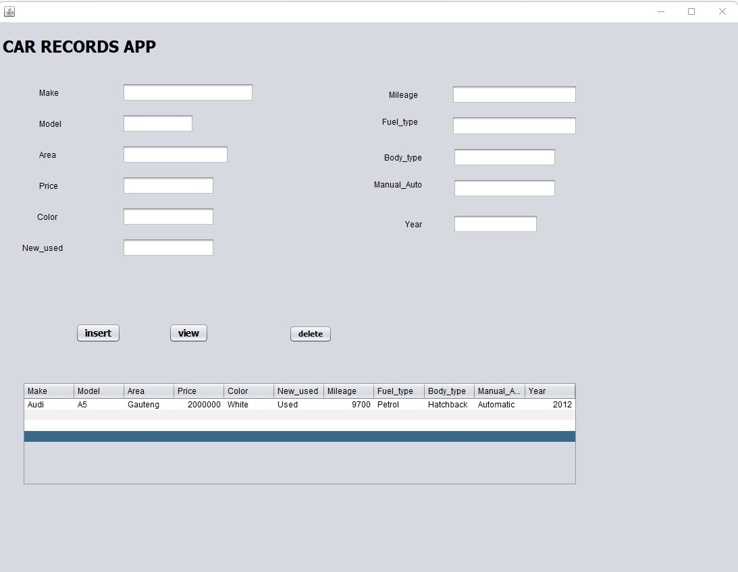

By clicking the **view button**, the data which we inserted which is the car records appears once you click the view button it is displayed on the JTable.

# Deleting records

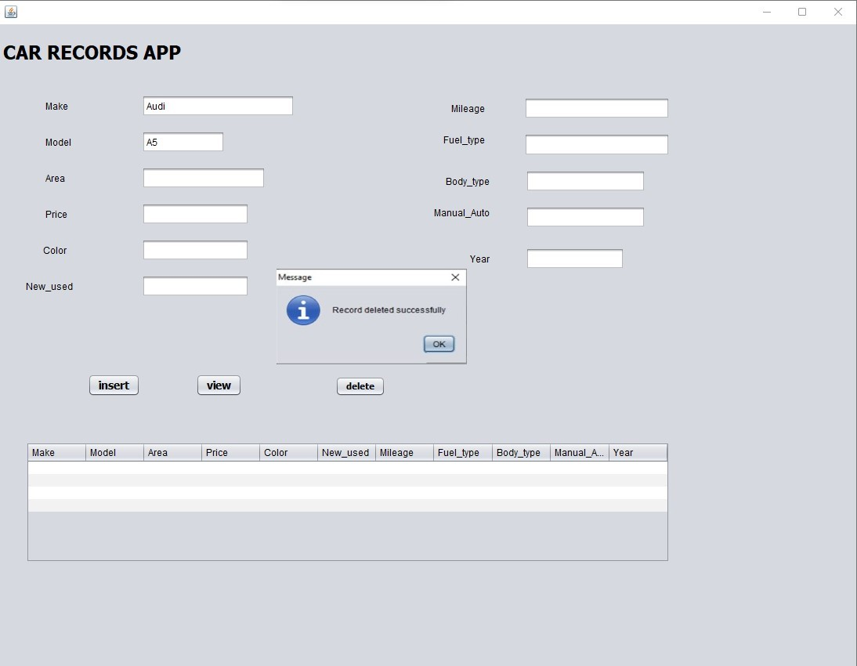

The user is able to delete the car records by entering the make and the model , all the car information is deleted from the database.

# Database & Tables

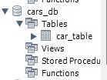 This is the **cars_db** database.

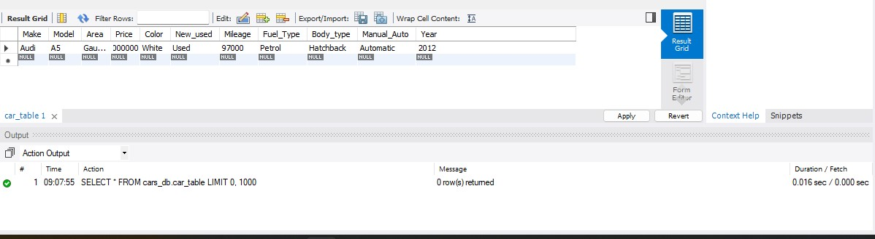

Above is the **car_table** which stores the information of the cars.